## horizontal line

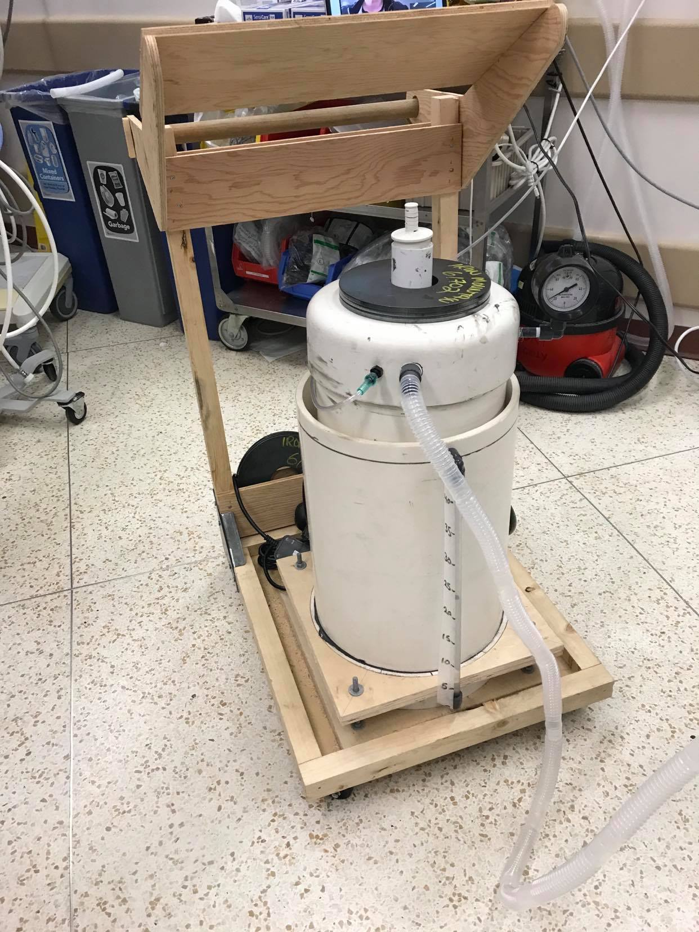

Fifty gVent Emergency Ventilators

HC-Certification Schedule and Cost Estimate

April 4th, 2020

UBC Sprint Open Source Emergency Ventilator Project

ubcsosevent.com

# 

# Overview

Last month, in the shadow of nationwide real-time expanding viral infection, Vancouver General Hospital (VGH) began looking for a local back-up source of Emergency Ventilators. Their challenge was - and is - to have a stockpile available, as well as to have local capacity available to produce many more in a very short period, in order to serve a wave(s) of arriving patients presenting with respiratory failure.

In response, a volunteer group started a project under the name of UBC SOS eVent. One of several ventilator products developed and tested to meet this challenge, is the gVent Emergency Ventilator.

These pages outline our plan and cost-estimate for building and delivering, on May 1st, 2020, a first shipment of fifty (50) gVent Emergency Ventilators, duly tested and individually approved by Health Canada, perhaps as Research, Proof-of-Concept devices, for temporary, emergency, “anti-pandemic” use in hospitals.

# Project Goals

1. Build and deliver fifty (50) HC-certified units to VGH, before May 1st, 2020.
   1. Prepare to deliver a second batch of units by June 1st, 2020, quantity subject to hospital request. Funding from unused contingency funds and/or more donations.
   2. Arrange one-year pledges from ISO 13485 certified firms, and associated suppliers, to remain stocked and tooled, ready to continue production at between 15 and 25 units per week.
   3. In May, establish and start the normal process to obtain full “Medical Device” certification for the gVent Ventilator.

# Specifications

**How it works:**

The basis of this system is gravity, water and two PVC pipes to create an inherently pressure controlled system capable of ventilation. Each pipe is sealed at one end, the outside pipe is closed at the bottom, with a smaller diameter pipe inverted inside it and open at its base. Water in the system allows a seal to be made between the two pipes. By introducing air into the system, the top pipe is displaced upwards from its resting position. The water seal prevents it’s escape and we create a storage of pressure. The created pressure is a result of the weight of the system pushing the water column downwards, and subsequently, the water column’s equal upward force on the trapped air.

Air is supplied by a constant flow of gas coming from the hospital’s outlet. The hospital tubing is attached to a nipple on the top of the inner PVC pipe (a ¼” fitting required for hospital tubing).

Air/O2 builds up in the system and once the valve to the patient is opened, it is released through a port to the intubated patient. This valve is controlled on an electronic circuit, which gives the operator the ability to control respiratory rate, I:E ratio and amount of volume delivered to the patient. When the valve is closed, air volume builds in the system, and the inner pipe slowly rises. When the valve is open, the net flow of air is out of the system (air flow in<air flow out) and the inner pipe falls.

The pressure in the system is dictated by the total weight of the inside pipe, and can be modulated by adding weights to the top of the system to gain higher pressures. The total surface area of the water column being pushed down in this specific system is 478cm2. Therefore, adding 478g to the top of the system will displace 486ml of water 1 cm, and increase the total pressure by 1cm H2O.

The overall weight of the system does not change significantly with a drop in height of the inner pipe (ignoring buoyancy forces on the pipe that used to be out of the water and is now underwater). Now that we know pressure is a result of weight, we know that the pressure will not change significantly with a drop in height either. It is only the volume of the trapped air that changes significantly. Thus, this system can be thought of as an air flow capacitor, storing extra air molecules but without making them significantly more compressed as more are added.

**Functional Block Diagram:**

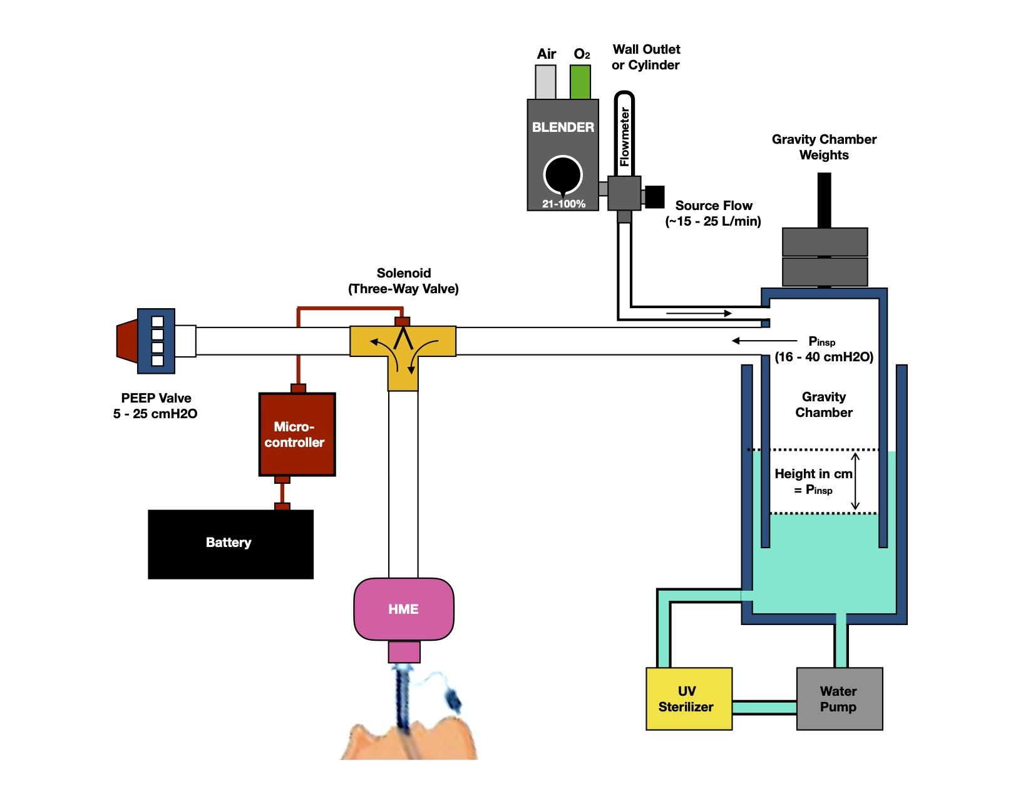

**Current Prototype:** The current prototype is a mass powered pressure chamber with a water seal. This system is capable of providing a constant inspiratory pressure with a built-in pressure limit. An oxygen blender provides the range of FiO2 settings, while a flowmeter provides the flow that pressurizes the gravity chamber. A solenoid alternates between the pressure chamber and the PEEP Valve, allowing for set inspiratory and set expiratory pressures. A microcontroller with analog interface allows for modification of Respiratory Rate and I:E Ratio. An HME filters expired air, keeping components free from secretions and other gross soiling, while providing passive heat and humidification.

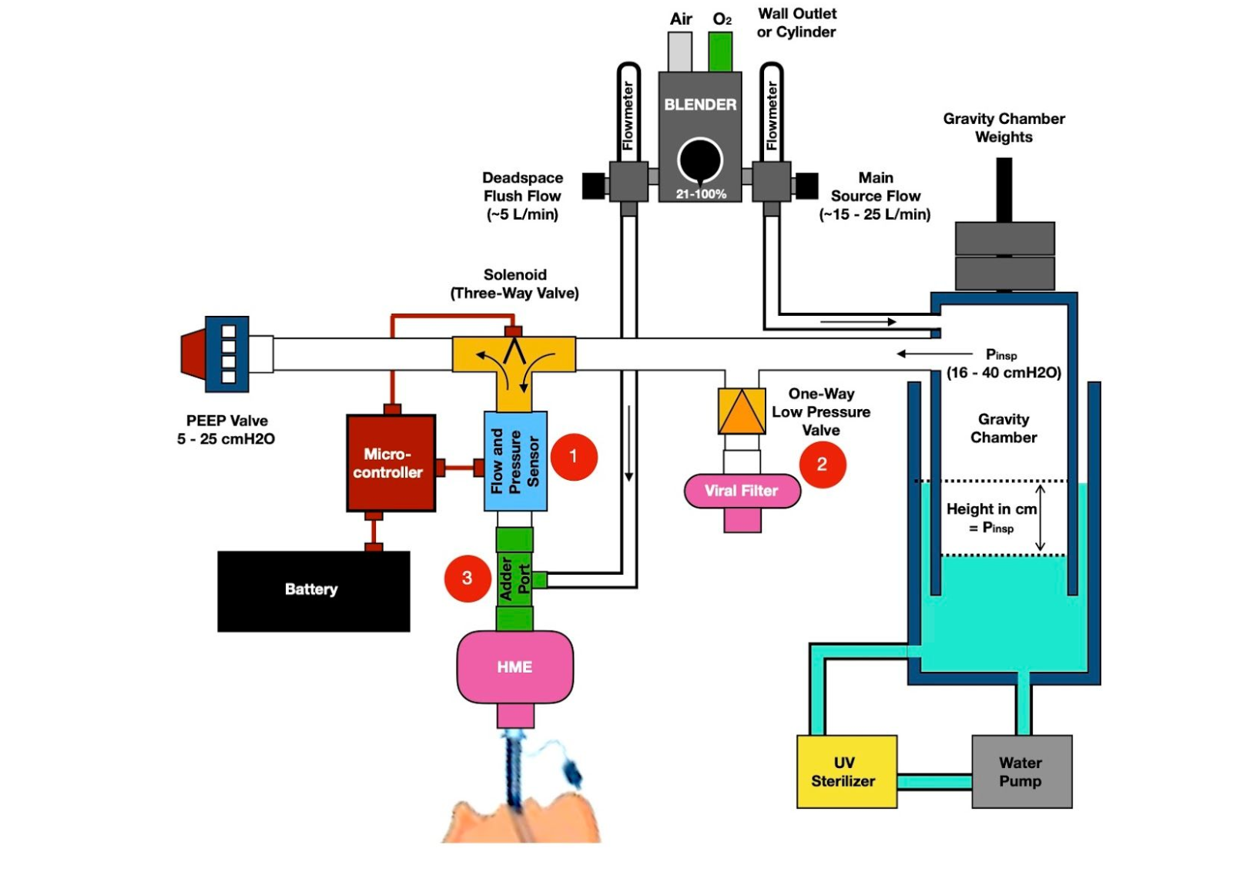

**Near Future Additions**: There are three planned essential additions that will improve the functionality and safety of this device.

The addition of a flow and pressure sensor will allow for pressure, volume, and flow monitoring, but also allow for sensing patient efforts. This will also allow for the inclusion of important volume and pressure alarms.

A one-way check valve will allow the patient to draw room air during the inspiratory phase in the event of a loss of pressure. This safety feature will prevent a possible draw of fluid from the gravity chamber into the breathing circuit. A filter ensures no contamination by air drawn from the room.

Given the single limb nature of the circuit, dead space will be an issue, and providing a flush flow will reduce rebreathing and also provide a flow to draw upon when triggering the ventilator.

We are awaiting delivery of parts that will allow us to incorporate these changes, and code has been written to integrate flow and pressure measurements.

# Milestones

## Development April 7-14

Establish, and confirm with HC, requirements/path to achieving certification

Line up certified fabrication capacity

Test and modify prototypes ( Code life..info).

Develop fab/test/cert schedule

Stop modifications, issue Fab drawings and BoM,

Purchase longest-lead components.

## Fabrication April 7-24

Product flow planning in a facility with ISO 13485 certification

Prepare assembly line and stations

Set up testing facilities as required for certification

Preliminary test schedule with dates and times for recording/witnessing

April 14: Line up suppliers for preliminary BoM

April 15: Start 1st units fabrication

## Testing and Certification April 20-30

Test every unit

## Delivery April 27-30

Deliver batches or, as convenient, for VGH

# 

# Cost Estimate

This is a Planning-level Budget Estimate. Material costs are based on construction of Prototype 3.0. To date, most hardware, software, and all development labour has been donated.

Goal #1:

50 Ventilators = $ 23,500

50 Control Systems = $ 7,500

HC device-level restrictions and approvals:

Fab, test, install, operate = $15,000

Shipping, Videography, Documentation, Labour = $ 3,000

Independent legal and medical consultation = $ 15,000

Sub-total: $ 64,000

Contingency (50%) = $ 32,000

Total: $ 96,000

Cost-centered Estimate

Materials Cost for Serial No. 1 gVent Unit (aka Prototype 4):*

Controls and sensors: $ 1,250

Valves - 10 x $60 = $600

Sensors: 5 x $80 = $400

Control Boxes (custom Fabrication): = $250

Gravity Chamber Components and Assembly = $ 500

Miscellaneous materials costs: $ 150

Sub-total: $ 1,900

For details, see: <https://docs.google.com/document/d/1-AcPzTlB4jOPGI5iO1yJyFzlaxSCQyAY76N6t1QBmhs/edit>

Assembly & HC-approval Testing for first batch of units (based on target qty of 50)

Facility space rental (4 weeks) = ~ $ 6,000

Machinist/Assembly/Test technicians, (2 x 40 hrs x 3 weeks x ave. $83/hr commercial rate) = ~ $20,000

Consultation Fees:

Fire and electrical safety approval (~10 hrs) = $ 1,500

Professional health and safety lead to set up and guide the approval process(30-60hrs) = ~ $ 6,000

Sub-total: $

Contingency (50%):

Total Estimated Cost for 50 units: = $ 0

Current Project Funds: (update on date of doc release, per Appendix B3)

Gap (50 units) : (update on date of doc release)

# Summary Statement

Using the concepts of water seals and pressure-operated devices, we have designed and built the **gVent** Emergency Ventilator. It is a fully-functional, affordable, scalable and reliable positive-pressure ventilator. We intend to introduce it, certified for hospital use, before May 1st, 2020.

For these first 50 units, (excluding contingency) our estimated unit cost of $1,280 includes ~$600 for materials and $520 to fast track assemble and meticulously testing every unit.

Most importantly, only by establishing a high level of communication and cooperation with Health Canada, will we succeed in co-creating and executing the necessary, rapid, regulatory process that will place approved gVents in hospitals by May 1st.

Estimate Accuracy

In these unusual times, it is impossible to determine all the costs and possible avenues of fast tracking a regulatory process which is in place to protect the public. For this reason, the 50% contingency is justified.

The number of units in the first production run may be totally dependent on necessary approval steps, and the perceived severity of the pandemic in the days ahead.

# Appendices

Contents Page

A1 How it Works

A2 Prototype 3 Description

A3 Near Future Additions

B1 Prototype 3 Bill of Materials

B2 Quality Assurance Plan